How to run the PatientMakeAppointmentPrototype

1. Make sure every file is in the same folder
2. Open the prototype project by using java or NetBeans
3. Run the file name “AppointmentSystem.java”

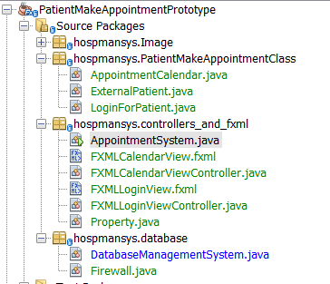

or

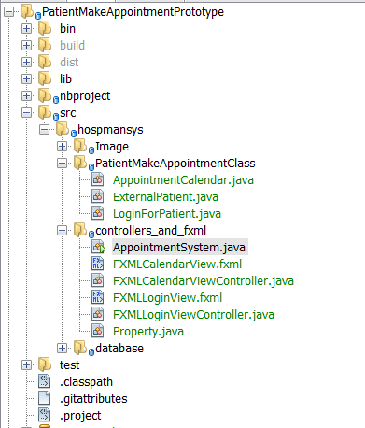

Or you can run the PatientAppointmentPrototype JAR file

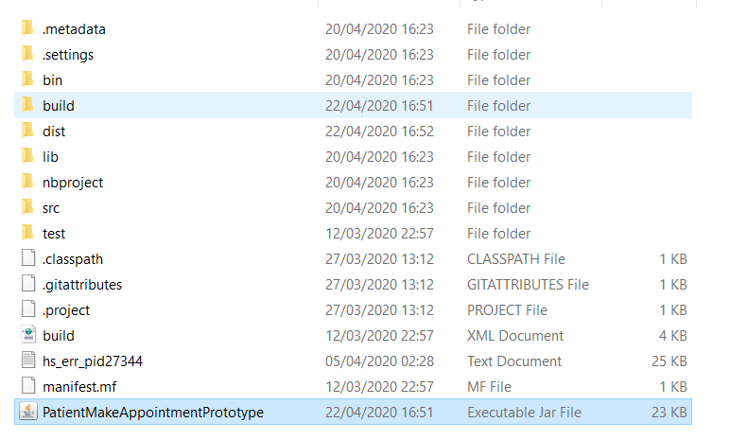

1. Once you have run it, it will bring you to login page:

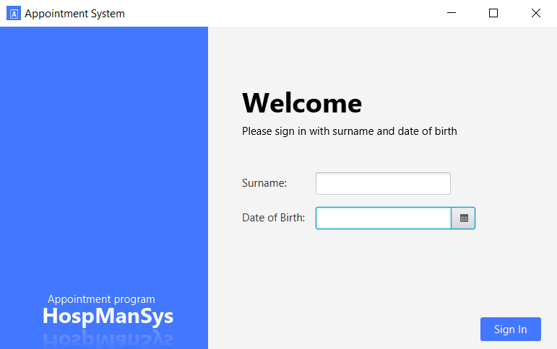

Enter Username: patient’s surname and date of birth: for login.

If you try to enter invalid details it shows an error dialogue box.

You can login by using the following surname and date of birth:

1. Wang, 2000-01-01
2. Wayne, 2001-01-01
3. Mad, 2002-01-01
4. Hang, 2003-01-01
5. Yang, 1999-01-01

**Here is patient’s detail:**

Name, Surname, date of birth, email

[Chris","Wang","2000-01-01","C.Wang@email.com](mailto:Chris","Wang","2000-01-01","C.Wang@email.com)

[Adam","Wayne","2001-01-01","A.Wanye@email.com](mailto:Adam","Wayne","2001-01-01","A.Wanye@email.com)

[Max","Mad","2002-01-01","M.Mad@email.com](mailto:Max","Mad","2002-01-01","M.Mad@email.com)

[Tomas","Hang","2003-01-01","T.Hang@email.com](mailto:Tomas","Hang","2003-01-01","T.Hang@email.com)

[Michael","Yang","1999-01-01","M.Yang@email.com](mailto:Michael","Yang","1999-01-01","M.Yang@email.com)

1. Once you Logged in successfully, it will bring you to calendar view:

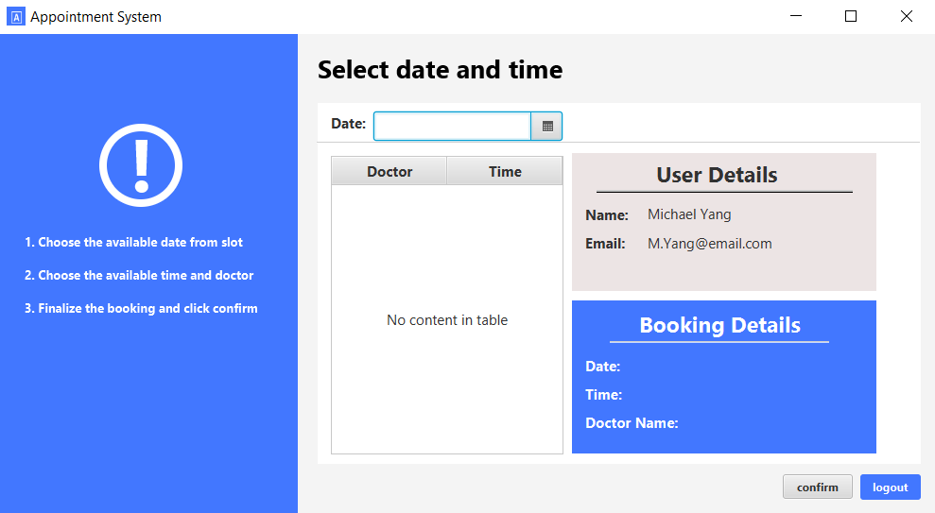

For example, logged in as Michael Yang

1. You can choose the date to make an appointment:

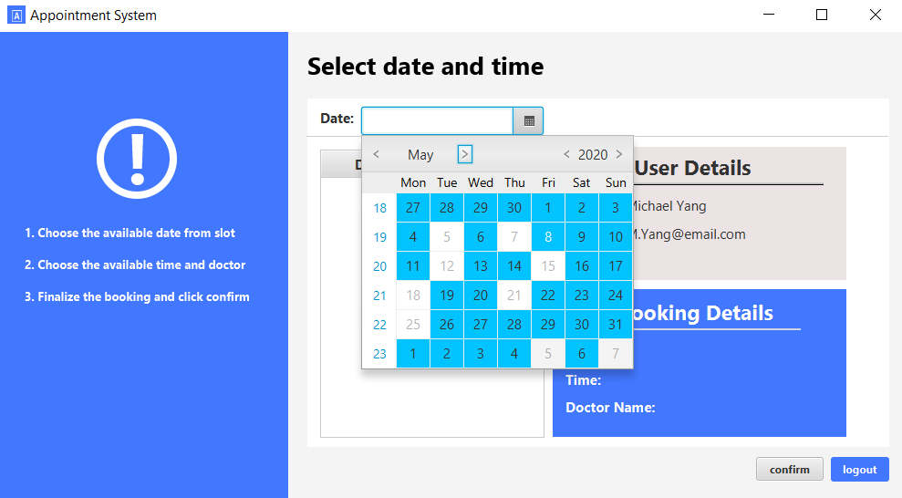

The available dates will be highlighted

1. Once you chose the date, the time slot of that date will be appeared:

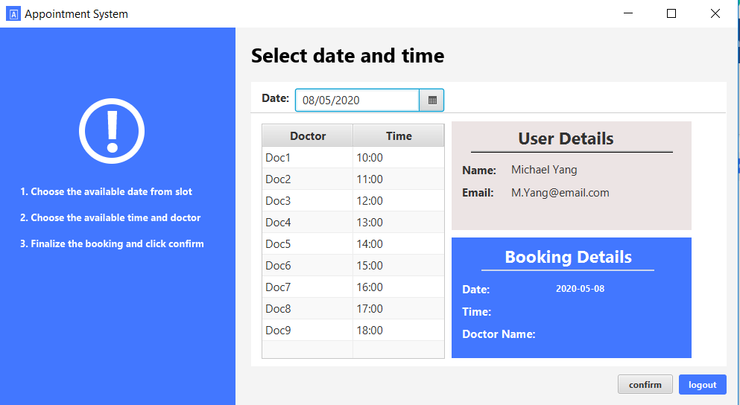

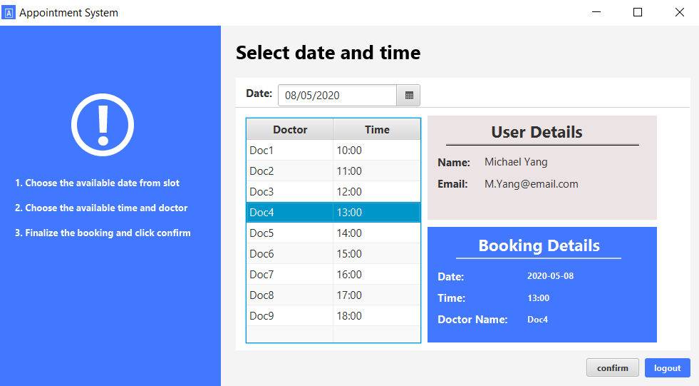

You can then select the time

1. Once you chose the date and time, you can then click confirm button:

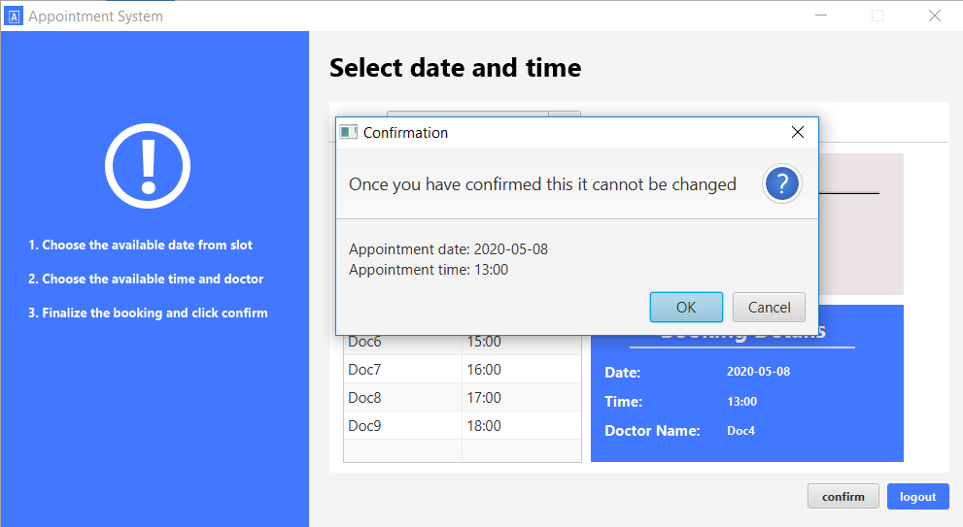

The confirmation pop up window will appear

1. Once you confirm your appointment, the program will update your appointment to the database:

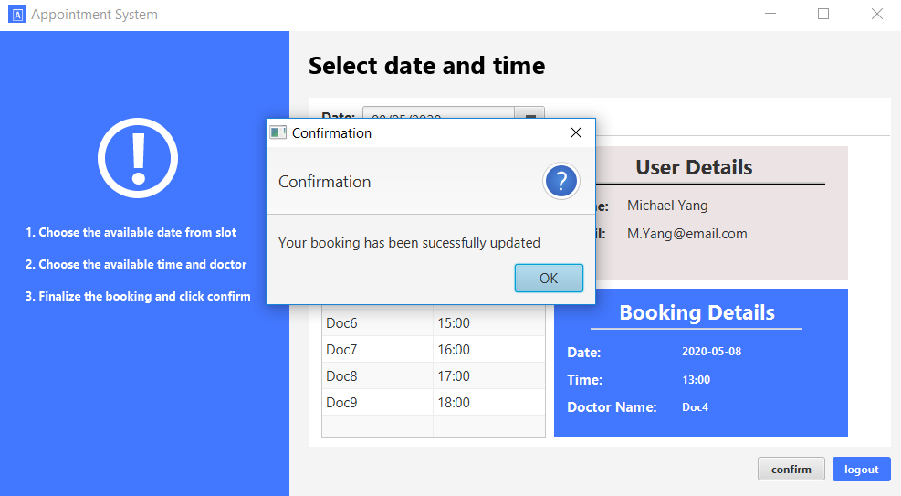

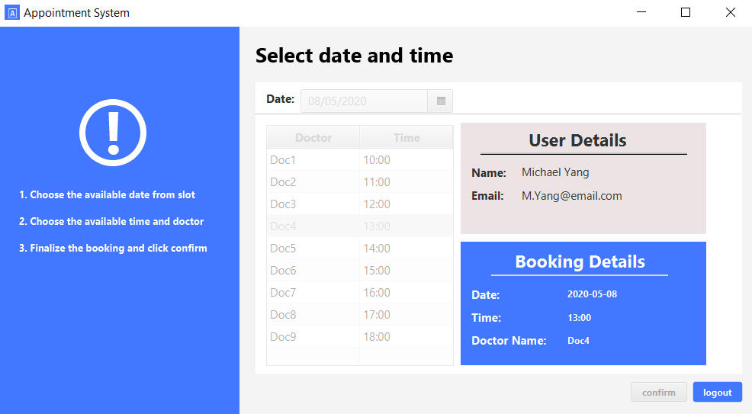

On the command line:

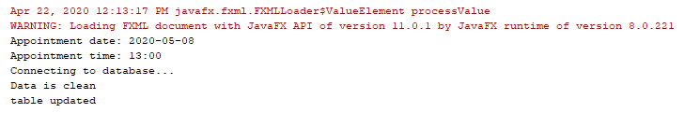

Table updated on the database:

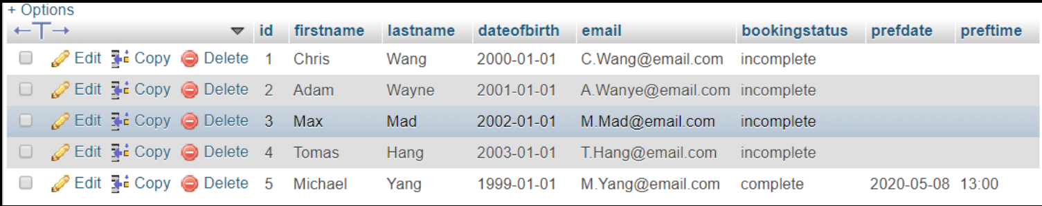

1. Once you finished everything, you can then logout:

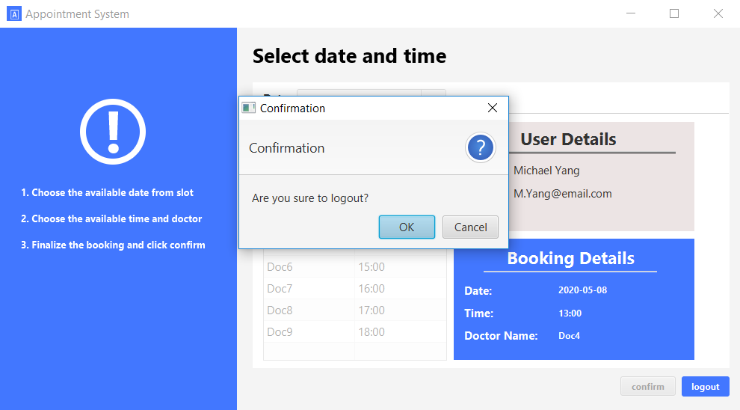

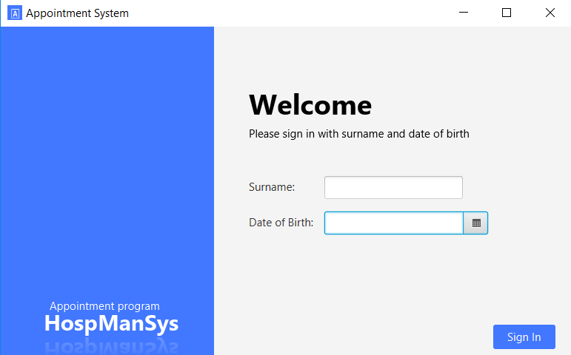

The system will bring you back to login page